Go Your Own Way!
https://www.youtube.com/watch?v=f1Fbpdhwqs8
This challenge is a little bit different. You have complete ownership over your learning and where you want to take this challenge. This will take 2 weeks so you need to think carefully about what you want to do. Before you start working through the reflective learning wheel that we use to frame our learning journey, you will need to think carefully about what it is you want to learn. Also consider what you can produce as part of this. You really want to show off your skills. You could do more than one outcome as part of your project – it is completely your choice!!
What is it that you are really interested in? Do you have a particular passion? What would you like to know more about?
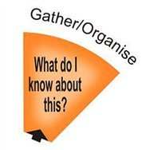 | - Create a page in your book which demonstrates what you already know about your area of choice for your project. If it is something that interests you, you may already have some knowledge about this.  - Make a list of questions of what you want to find out – this will help guide you as you research and create.
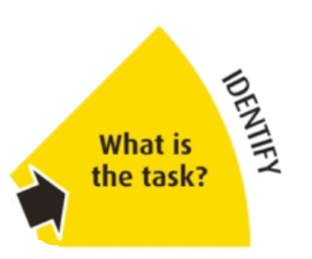 | - Create a page in your book which showcases what the task is. You could use the description above to help you write out what the task is but you will need to personalise it to your project of choice.  - Make a list of the skills you need to develop, the knowledge you need to learn and who could help you e.g. experts.  - Decorate the page with pictures related to the task.
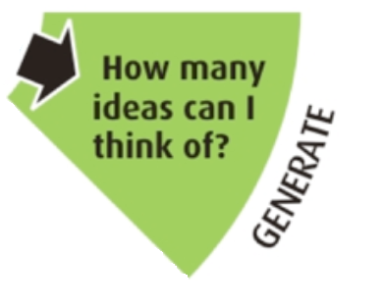 | - Create a mindmap of things which you could find out about and include in your project. Write down as many ideas as possible.  - For this challenge, you might like to write down ideas of the options of what you can produce for your outcome which might include a presentation, art work, sculpture, drama etc. You don’t need to do everything but you might like to do more than 1.
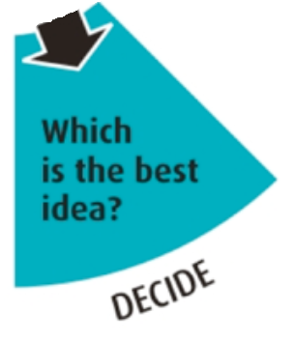 | - Make a list of the BEST ideas you have had. Make sure at least one idea requires you to write something. Make sure your ideas match what the task is.  - Make a list of any skills or knowledge you might need to be able to achieve your outcome.
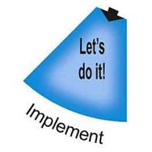 | - You will need to develop the skills and knowledge that you said you would need in the last section. This might require some research or you may need to find some tutorials. Record all of your learning in your book.  - Produce your final outcome!
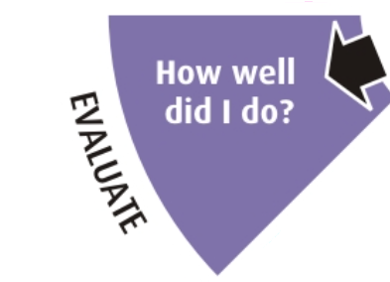 | - Did you manage to complete the task?  - What went well?  - What could have gone better?
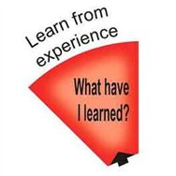 | - Create a new mindmap of anything you have learned this week whilst doing the challenge
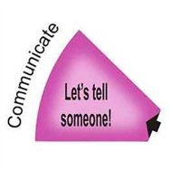 | - Email all of your work from this challenge to your teacher! Is there anyone else you could share your achievements with? Well done!

Notes for parents/carers:
- At school we use the TASC wheel to help the children think through a task or a problem. The whole TASC wheel is seen below.
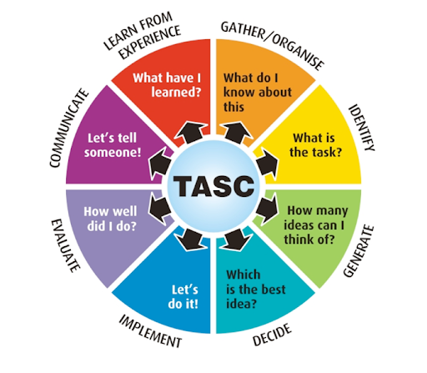
- To support your child in going through the process, we have broken down each segment and we have given suggestions about what to do at each stage. You will notice that this is similar to the process that the teachers have been taking you through during the other challenges.
- Depending on the task or problem, not all segments need to be filled in. Some weeks you might find that some of the segments from the TASC wheel are not in the outline, that is because it is not appropriate/necessary to fill it in.
- The sections will take the children different amounts of time to complete. On some days you will be able to do more than one section. The biggest of the sections is the ‘let’s do it’ stage which is likely to take between 2 and 3 days to complete. The second biggest stage is ‘how many ideas can I think of?’ time should be spent researching and gathering ideas.
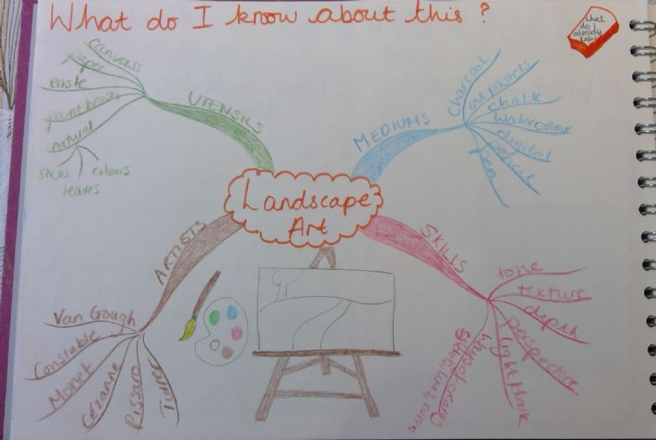
- The children can use different methods of recording in each section. This could include mindmaps, lists, flowcharts, written paragraphs etc. The ‘let’s do it’ section is where the outcome is created. Below are some examples of work from each stage of the TASC wheel. Please note that the children can be creative and do not have to set it out exactly like the examples, they are just there for ideas. You can look back at previous challenge work that teachers have set for more examples of what each stage might look like.
2. What is the task?
(example from a story writing experience)
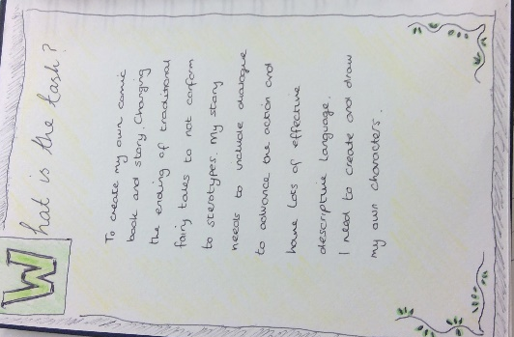
1. What do I already know?
(example from view from the window art challenge)

3. How many ideas can I think of?
(example from a cake experience and time capsule experience)
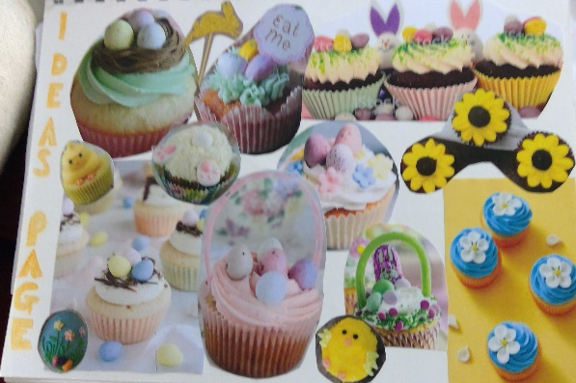
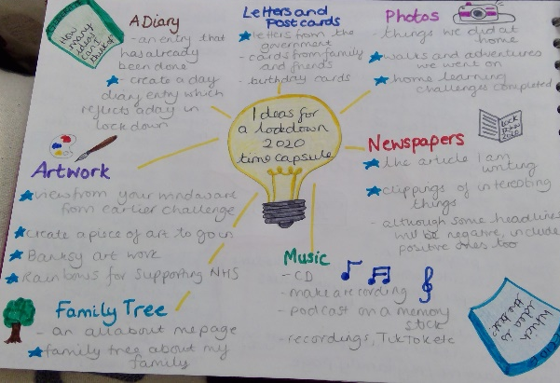

4. What’s the best idea?
(example from the puppet show challenge)
5. Let’s do it!
(example of plant challenge learning and the poem from the view from your window challenge). This will be whatever the outcome was and the research you needed to do to get there.
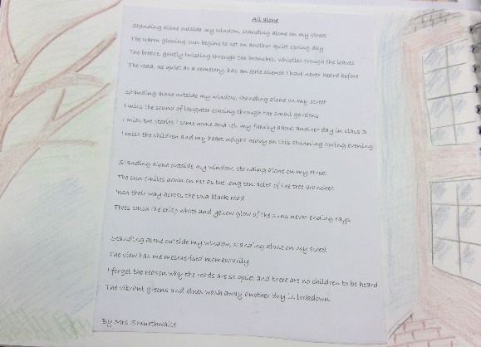
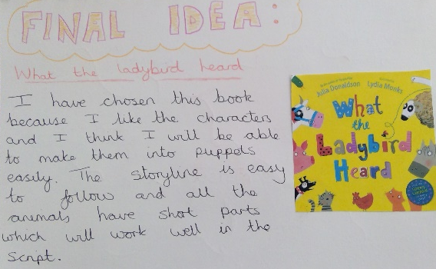
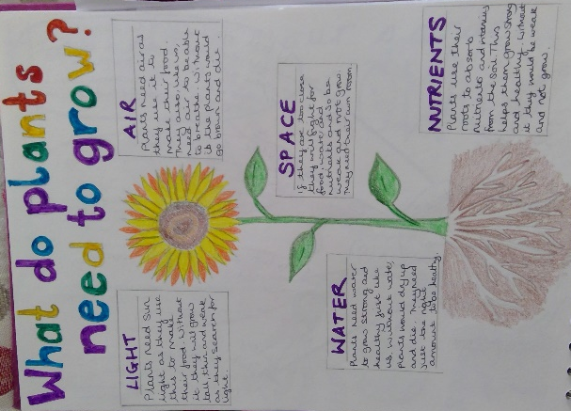
6. How well did I do?
(example from cooking challenge)
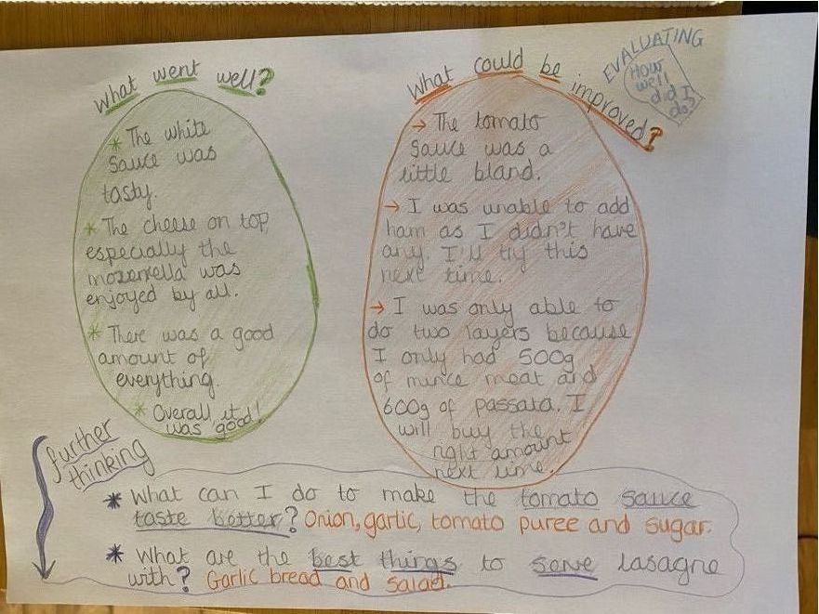
7. Let’s tell someone!
This doesn’t necessarily need a page in your book because this is where you share your learning with others.

8. What have I learned?
(example from exercise challenge and nutrition challenge)
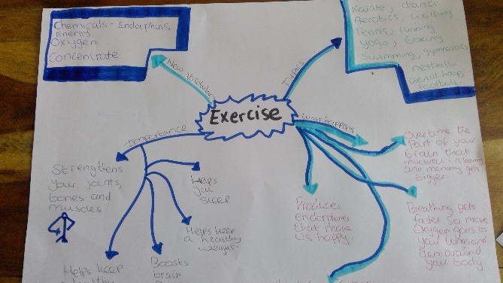

Please note that the examples provided have been created by teachers from reception to year 6.
There are lots of different ways of presenting work from each stage. Be creative in your approaches to each challenge.
The quality and quantity of the work produced will differ according to the age and ability of your child. For examples of other children’s work you can visit each classes celebration pages.

