Time | Learning
9-9:30 | Joe Wicks virtual PE – bodycoachtv on youtube.com (Joe Wicks will now only be on a Monday and Wednesday)
9:30 – 9:50 | Guided reading/Lexia  If you are a Lexia person you must complete Lexia during this time instead of guided reading.  Those of you doing the guided reading, please spend today reading the text and familiarising yourself with it. It is quite long and we will be using it all week so make sure if there are any words you don’t know please find out what they mean so that the text makes sense and you are confident and ready to answer questions on the other days.
9:50-10:30 | Maths  LO: to read coordinates in the first quadrant.  SC1: I can label the x-axis and y-axis.  SC2: I know that a coordinate is represented by two numbers in brackets, separated by a comma.  SC3: I can read a coordinate correctly by going along and then up.  https://youtu.be/-Ekmosfm4YA  At the Bakery: Using the scene displayed on the Lesson Presentation, rehearse the language of position and direction by making mathematical statements about the objects within the picture. Use the word banks of vocabulary if you need a bit of extra support with this.  Reading Coordinates: Use the information and images on the Lesson Presentation to explain that a coordinate is a way to locate a position on a map or graph by indicating how many units along, and how many units up the position is. The x-axis, y-axis, and quadrant features of coordinates and they are recorded inside  brackets, separated by a comma. Co-ordinates must be read in the correct order; along then up.  Coordinates Match Up: Using the 8 grids on the PowerPoint, record where the green dot is. Make sure you record accurately and check your answers.  Mixed up Coordinates: look at the discussion cartoons displayed on the Lesson Presentation and discuss which answer is correct and why.  Café Coordinates: Choose your challenge. 1 star is the easiest and 3 star is the hardest. If you choose a challenge and it is too hard, don’t finish it, swap to an easier one. Similarly, if you choose one that is too easy, swap to a harder one. Think about which star challenge I normally give you at school.  If you finish this and you want an extension, I have added one but do not spend ages doing this. Only do the extension is you have time. This will really work on your justification and reasoning which is a very important part of your maths curriculum. Year 4 you should definitely give this a go if you have time.  Coordinate Menus: The reasoning problems on the Lesson Presentation ask you to identify the items each customer has ordered from the menu by reading the coordinates accurately.
10:30-11:00 | Break time/snack time
11:00 – 11:45 | English  LO: to identify the key features of a variety of newspapers  SC1: I can name and explain the purpose of each feature  SC2: I know the order each feature comes in for most newspaper articles  SC3: I can explain what each feature means and identify it within a text  https://youtu.be/wnItQjEDyec  This week as part of challenge number 11 we will be writing a newspaper report about what life is like in lockdown 2020. Whenever we start a new type of writing we start by investigating existing examples and identifying the features. That way we can use this to help frame our own writing. Go onto the BBC bite size website using the link and watch the short video about newspaper articles to get you thinking about this.  https://www.bbc.co.uk/bitesize/topics/z2yycdm/articles/z2gk9qt  Now open the PowerPoint which works through the features we are going to be concentrating on identifying in newspaper articles.  Activity: I have chosen an article from First News (the children’s newspaper that we have delivered to school and you find in our classrooms) about Zoos possibly closing. Use the features list to identify them in the text (headlines, paragraphs, connectives, quotes, photos and captions and 5ws). Remember, the SC is to identify and explain so look at my example to help you with how to do this.  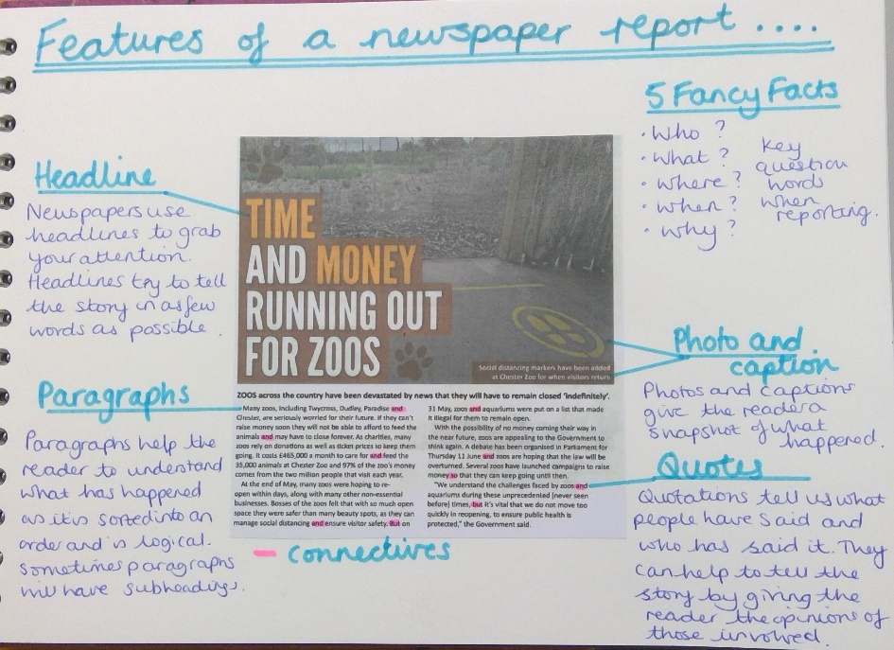  Extension: if you have time or you would like to there is an extension available. You do not have to do this but try it if you can. As time progresses, more and more is available online. This includes newspapers too. I have provided an online article that you can look at. https://www.bbc.co.uk/newsround/53050926  Are the features different or the same to the other article? Are there any features missing or that has been added? Do you think online newspapers or paper versions are better? Can you justify your answer?
11:45- 12:15 | TTRockstars  Make sure you do at least one sound check and one studio session. Try to get as many right as you can in the fastest time possible. Remember you want to be aiming for less than 6 seconds to answer a question correctly.
12:15- 1:15 | Lunch
1:15- 2:00 | Gather/Organise – What do I already know about this?  LO: to recall what I already know about time capsuling  Watch the challenge by Mrs Mitchell and Miss Fermor.  https://www.youtube.com/watch?v=iwBjzj1mfIo  https://youtu.be/GtTVTuBPuEA  At the beginning of every challenge we organise what we already know about things. This should be bright, colourful, have pictures and be well organised. You can present the knowledge you already have in a way that you feel comfortable but it needs to be done hand. You might have some pre-existing knowledge about time capsules or you may know nothing about it at all and that is fine. Still create your first page. Make sure you display this and really show what you already know. Have a look at mine for some ideas of what you could do.  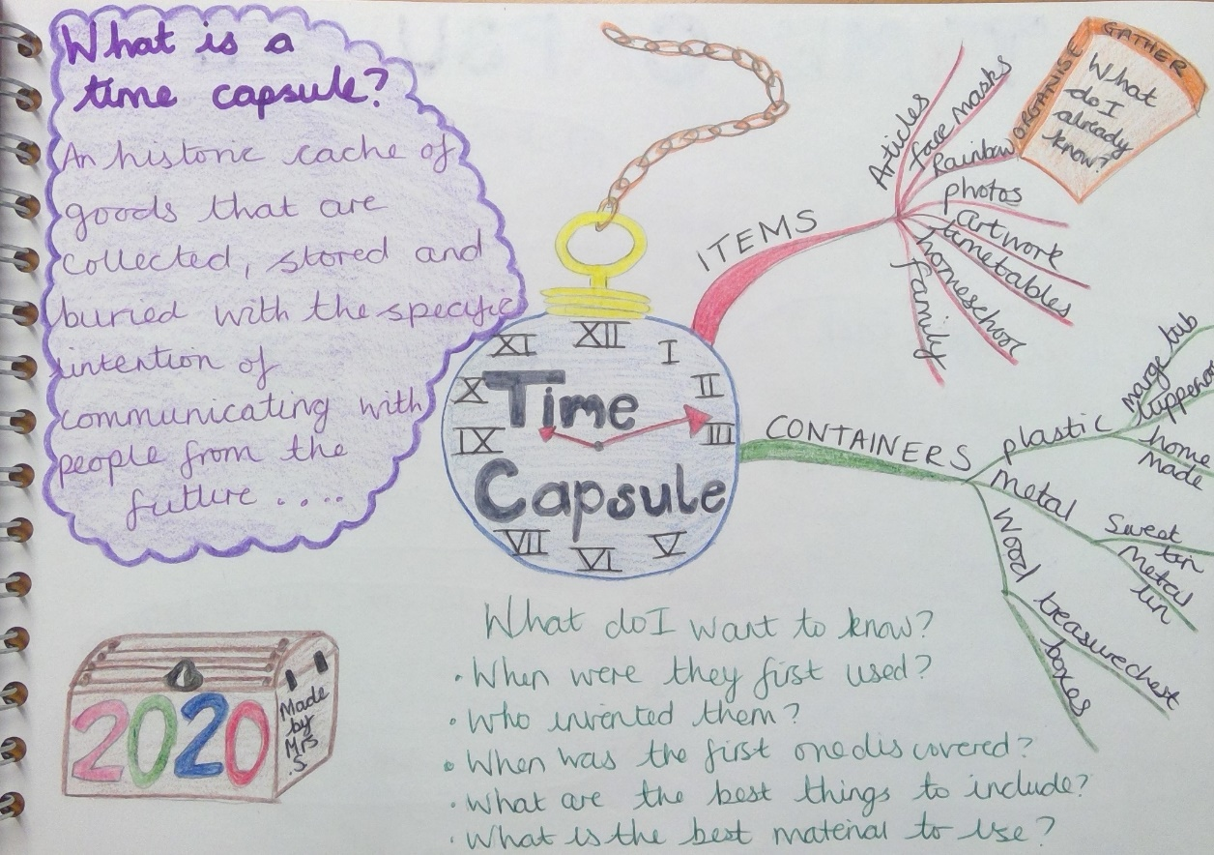
2:00- 2:30 | Exercise – e.g. mindfulness yoga, fresh air in the garden, run up and down the stairs seeing if you can get faster every time!
2:30-3:00 | Identify – What is the task?  LO: to explain what the task is and identify what may need to be learned, sourced or asked in order to do this  https://youtu.be/v1Qp43T2Hl0  Make sure you have watched the video by Mrs Mitchell and Miss Fermor so that you understand what the challenge is for this week.  In your book, explain in your own words what the challenge is. Is there anything you will need to find out in order to be able to achieve it? Is there anything you need to get? Is there anyone you need to ask for help with it? Are there any skills that you don’t yet have that you need to learn? Have a look at my example as one way of displaying your work but remember you can do this in any way you want to. You are in charge of how you present your work.  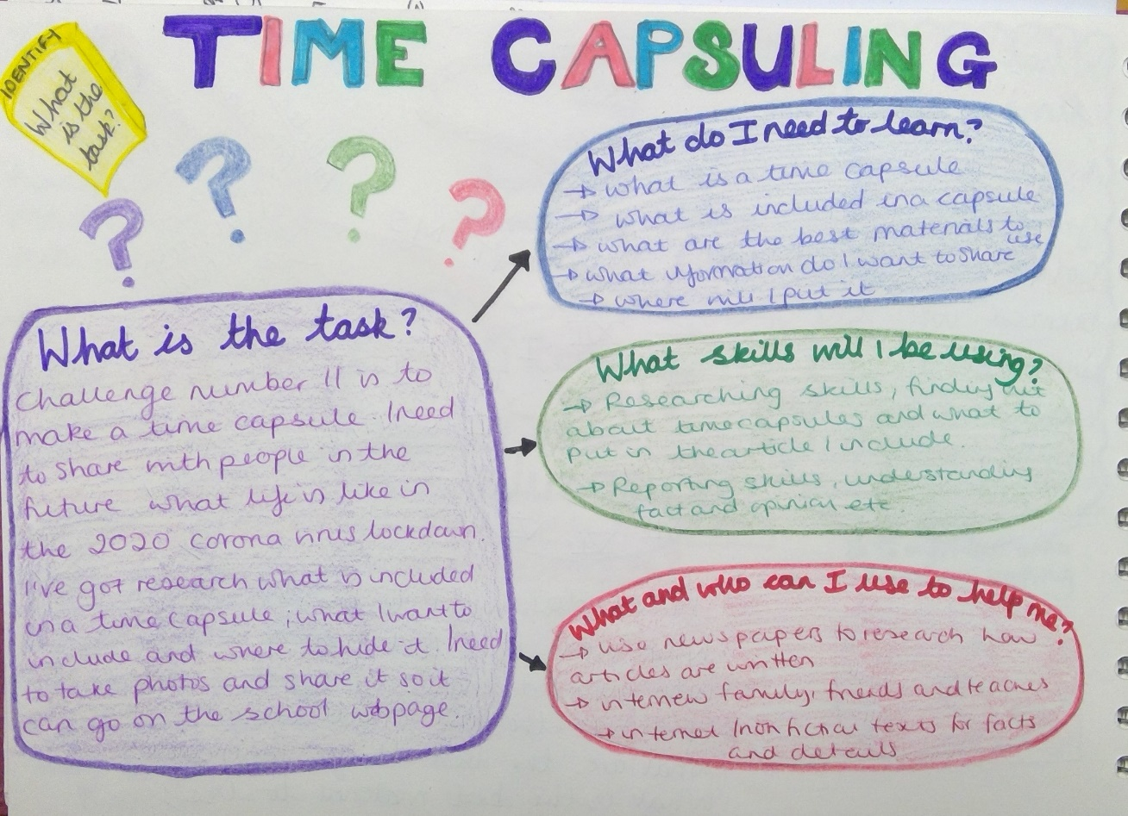
3.00 – 3.15 | Federation Story Time!!  https://www.youtube.com/watch?v=aGLdmLFrbZQ

