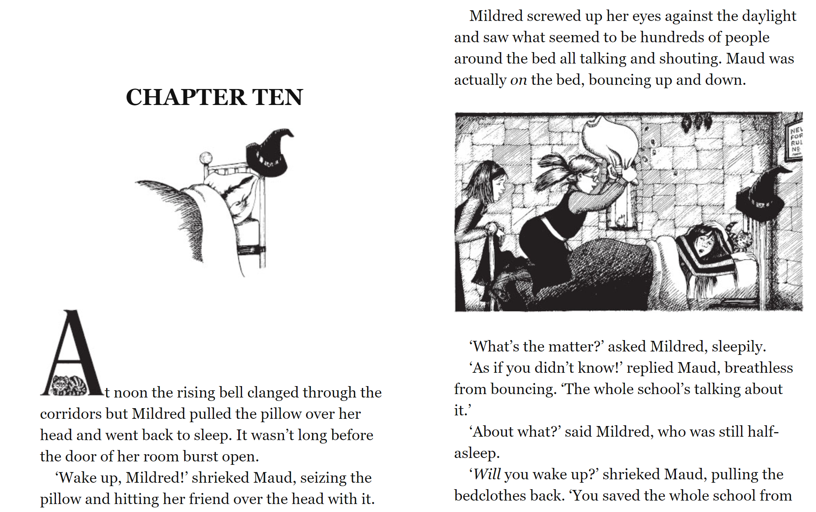

page 1

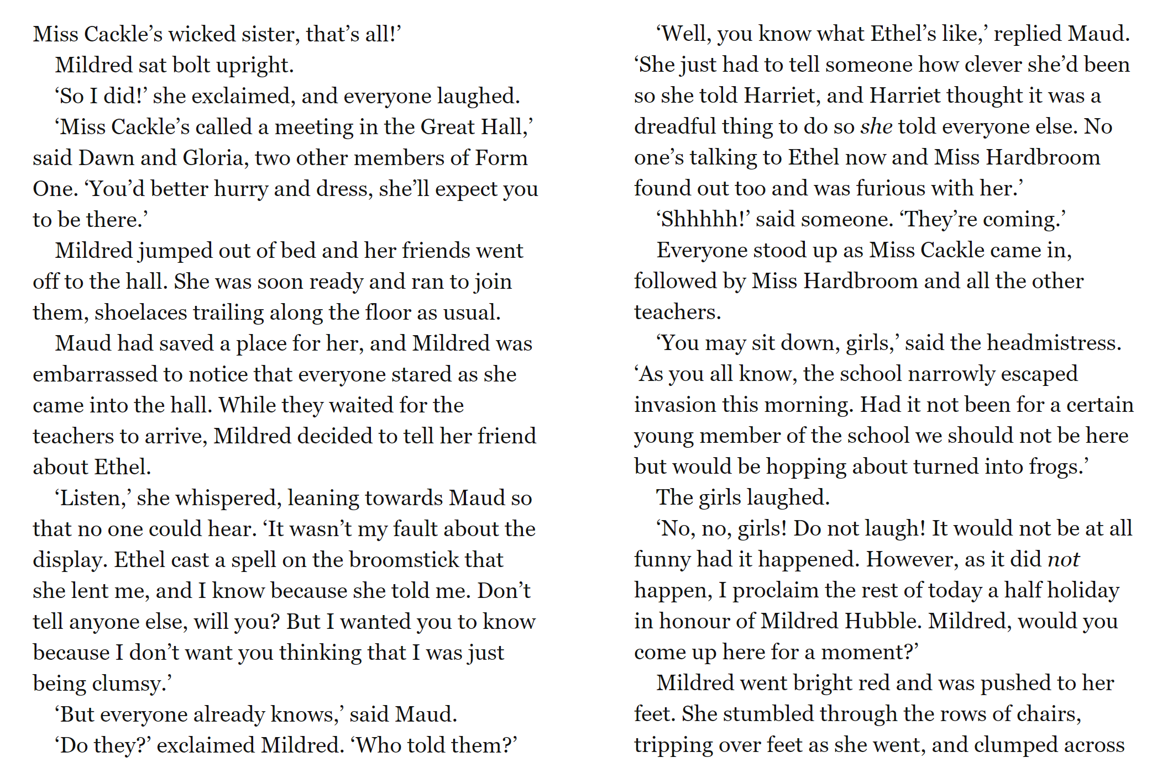

page 2

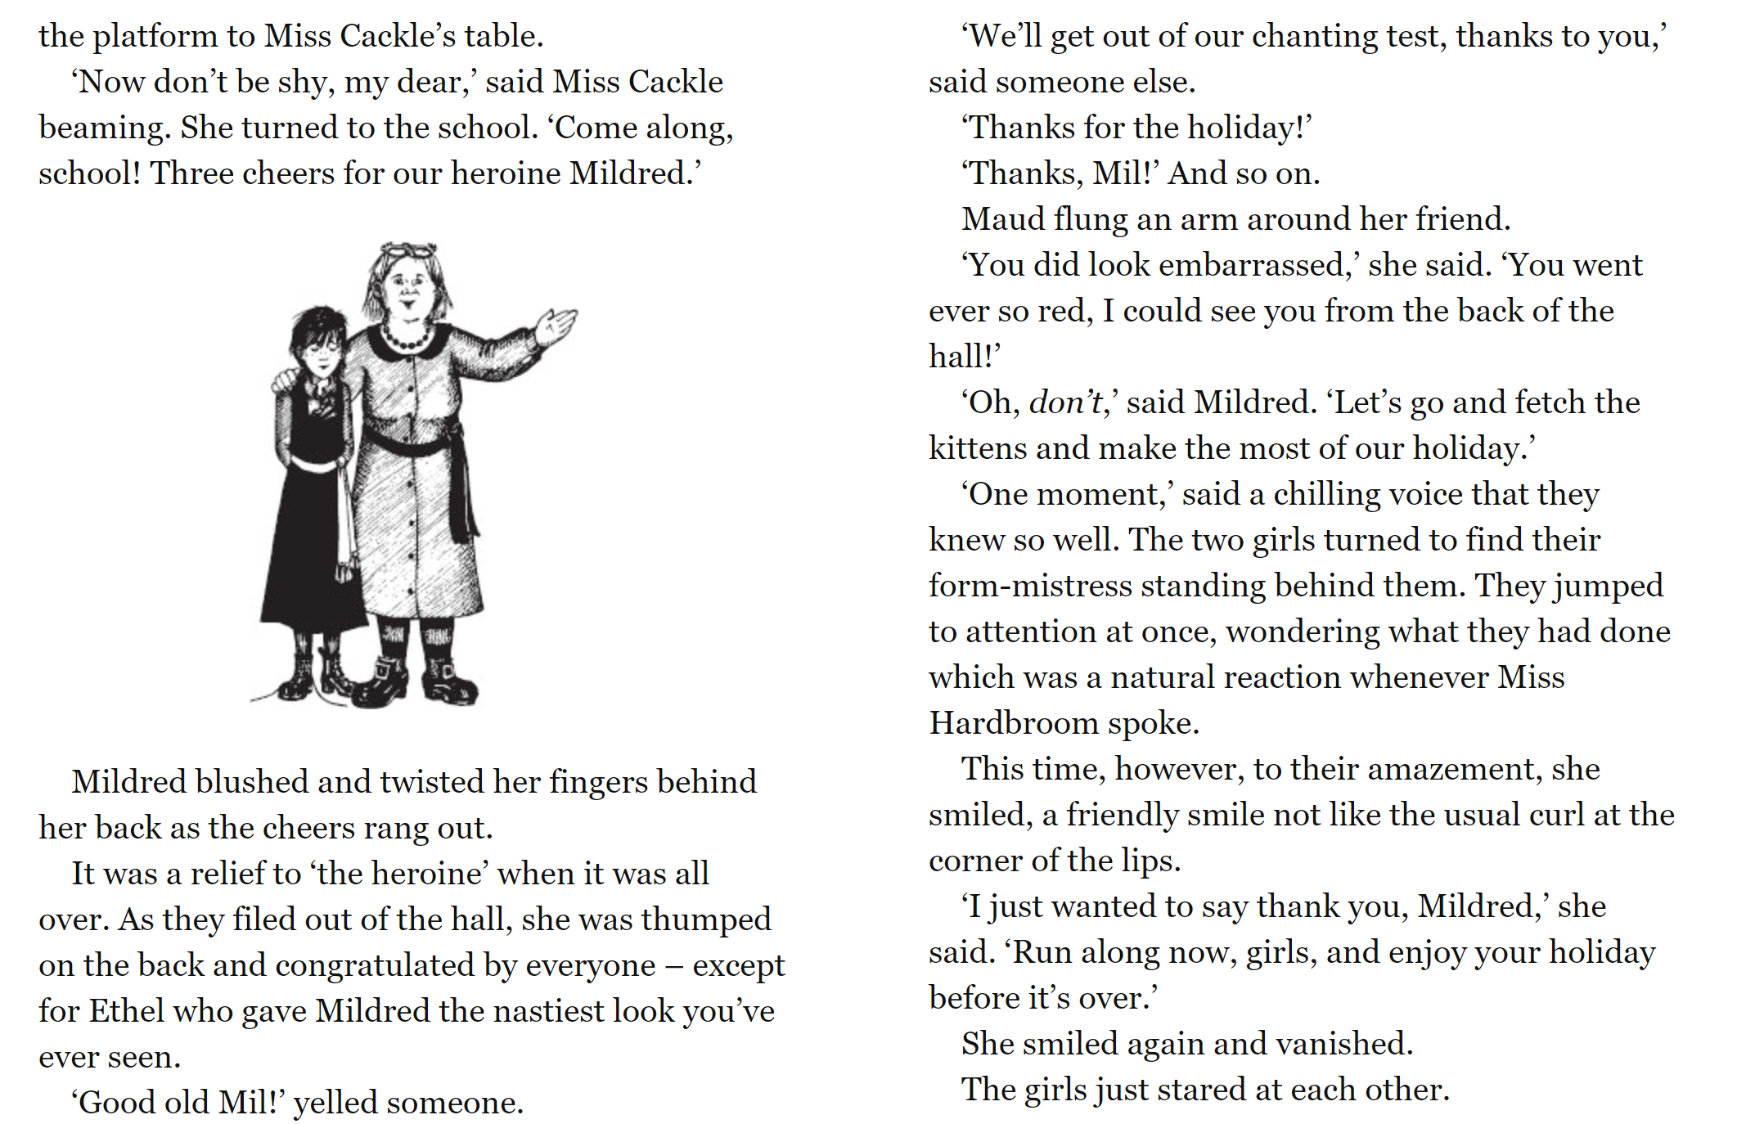

page 3

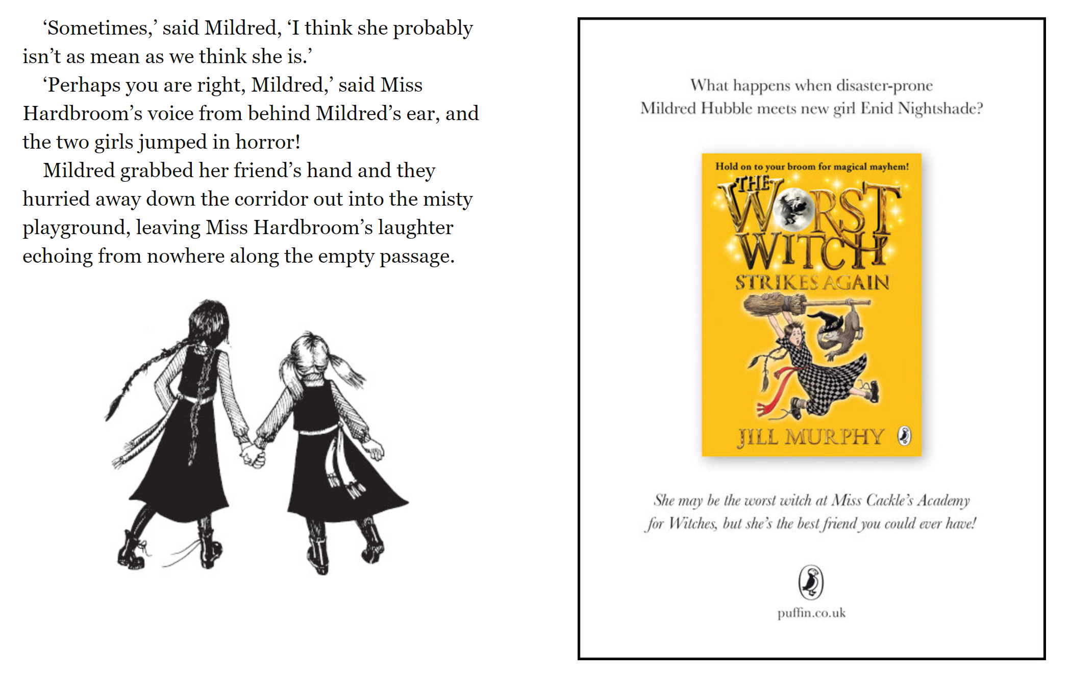

page 4

**I hope you enjoyed reading The Worst Witch by Jill Murphy.**

**Your task today is to write a book review, which can be used to encourage other children to read The Worst Witch ☺**

**There is a book review writing frame attached to our class page if you would like to use it to help you.**

page 3