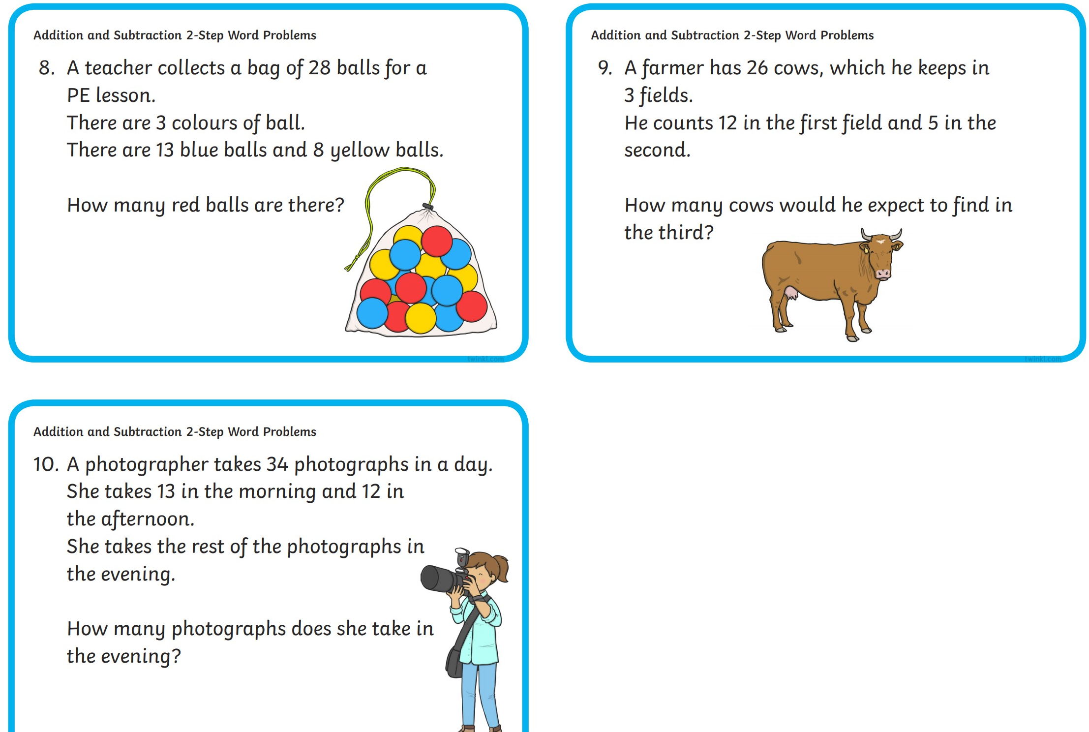

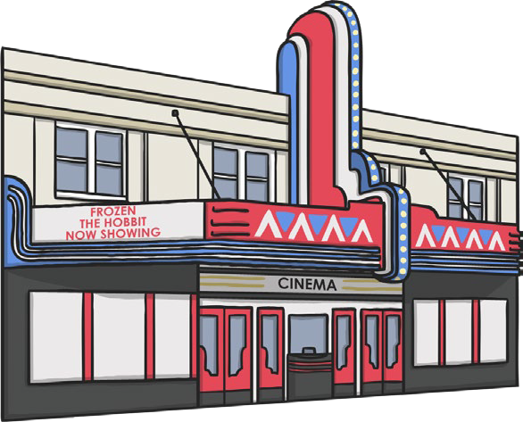

The cinema has 100 seats . 38 adults and 37 children come to see the film. How

many empty seats are there?

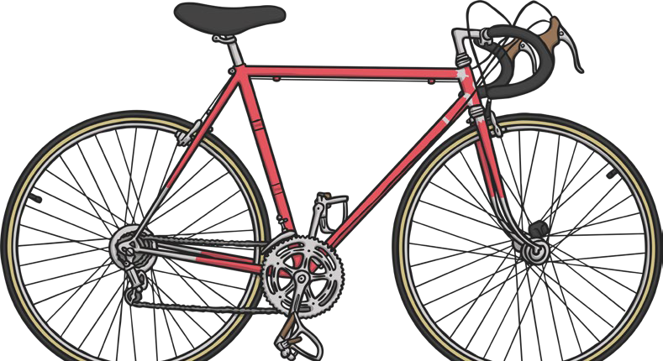

**Two-Step Addition and Subtraction Word Problems**

Dorothy is saving her money for a new bike costing

£89. If she has already saved £39 and is then given £29 for her birthday, how much more does she need to save?