Time Warp!!
https://www.youtube.com/watch?v=iwBjzj1mfIo
For this challenge you need to create a time capsule to tell people in the future about your life during the corona virus. You will need to think about what would be the best things to include in the time capsule. You will want to include a range of things in your capsule but ideas for things that you could write might include letters, diary entries or newspaper articles. You will then need to think about where best to hide your time capsule.
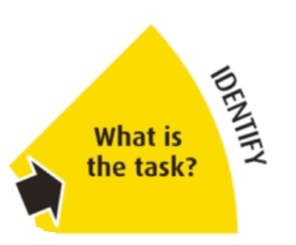 | - Create a page in your book which showcases what the task is. You could use the description above to help you write out what the task is.  - Decorate the page with pictures related to the task.
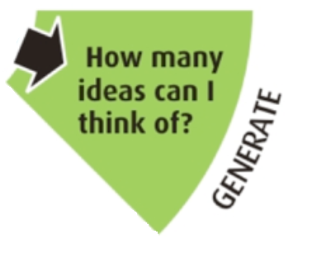 | - Create a mindmap of things which you could put in the time capsule. Write down as many ideas as possible. You might need to do some research on time capsules.
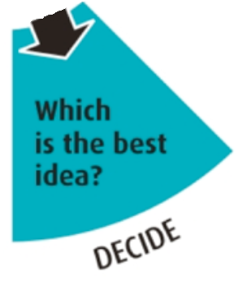 | - Make a list of the BEST ideas you have had. Make sure at least one idea requires you to write something. Make sure your ideas match what the task is (e.g. it needs to inform people about life during the coronavirus).  - Make a list of any skills or knowledge you might need to make the things that will go inside your time capsule. For example, if you are going to write your own newspaper article, what do you need to learn about in order to be able to create one? (how a newspaper is set out, what to include etc).
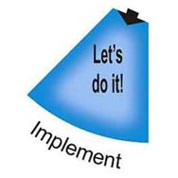 | - Get to work making all the things to go in your time capsule.  - You will need to develop the skills and knowledge that you said you would need in the last section. This might require some research or you may need to find some tutorials. Record all of your learning in your book.  - Once you have made your time capsule, take photographs of it and hide it.
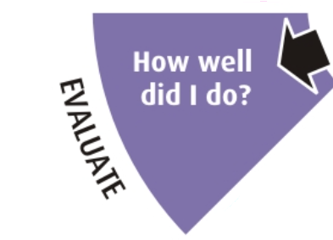 | - Did you manage to complete the task?  - What went well?  - What could have gone better?
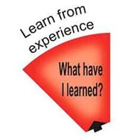 | - Create a new mindmap of anything you have learned this week whilst doing the challenge
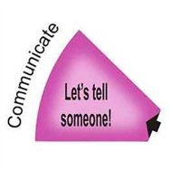 | - Email all of your work from this challenge to your teacher! Well done!

Notes for parents/carers:
- At school we use the TASC wheel to help the children think through a task or a problem. The whole TASC wheel is seen below.
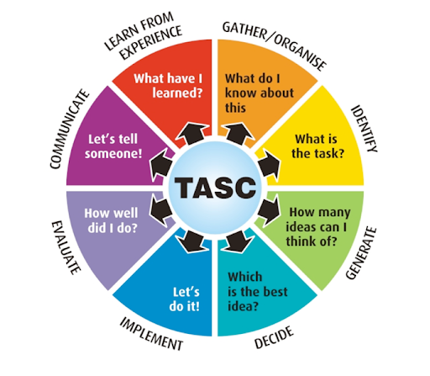
- To support your child in going through the process, we have broken down each segment and we have given suggestions about what to do at each stage. You will notice that this is similar to the process that the teachers have been taking you through during the other challenges.
- Depending on the task or problem, not all segments need to be filled in. Some weeks you might find that some of the segments from the TASC wheel are not in the outline, that is because it is not appropriate/necessary to fill it in.
- The sections will take the children different amounts of time to complete. On some days you will be able to do more than one section. The biggest of the sections is the ‘let’s do it’ stage which is likely to take between 2 and 3 days to complete. The second biggest stage is ‘how many ideas can I think of?’ time should be spent researching and gathering ideas.
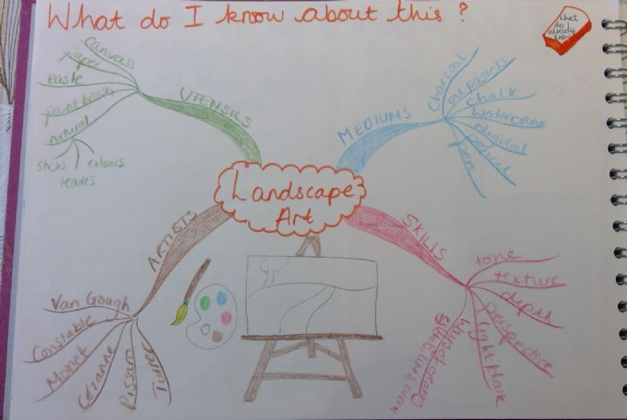
- The children can use different methods of recording in each section. This could include mindmaps, lists, flowcharts, written paragraphs etc. The ‘let’s do it’ section is where the outcome is created. Below are some examples of work from each stage of the TASC wheel. Please note that the children can be creative and do not have to set it out exactly like the examples, they are just there for ideas. You can look back at previous challenge work that teachers have set for more examples of what each stage might look like.
2. What is the task?
(example from a story writing experience)
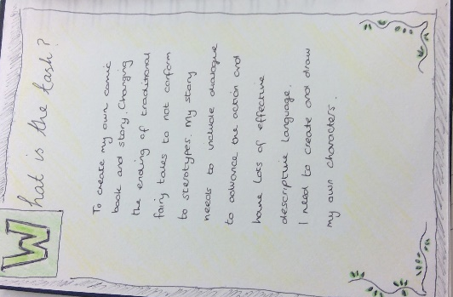
1. What do I already know?
(example from view from the window art challenge)

3. How many ideas can I think of?
(example from a cake experience and time capsule experience)
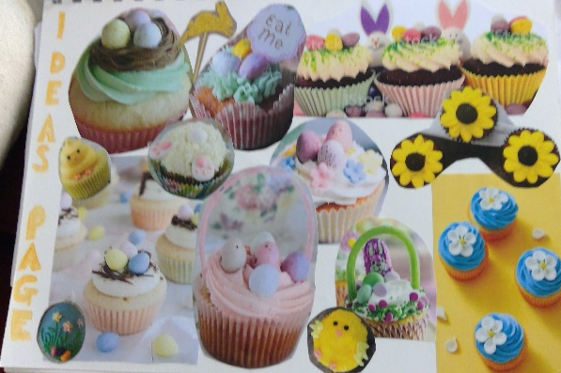
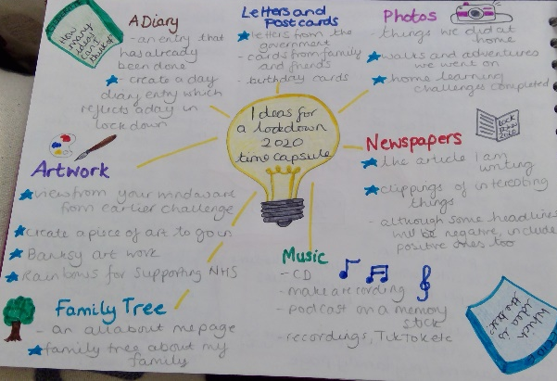

4. What’s the best idea?
(example from the puppet show challenge)
5. Let’s do it!
(example of plant challenge learning and the poem from the view from your window challenge). This will be whatever the outcome was and the research you needed to do to get there.
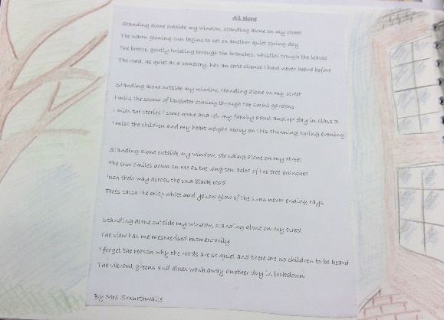
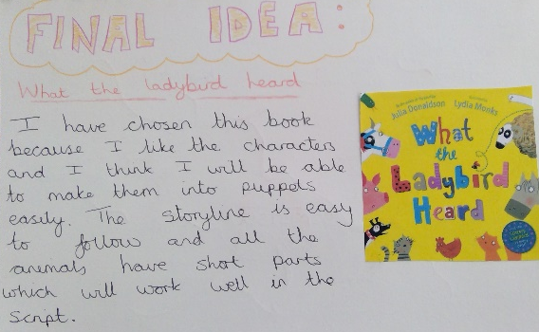
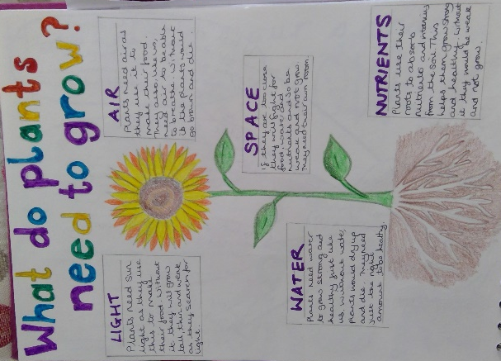
6. How well did I do?
(example from cooking challenge)
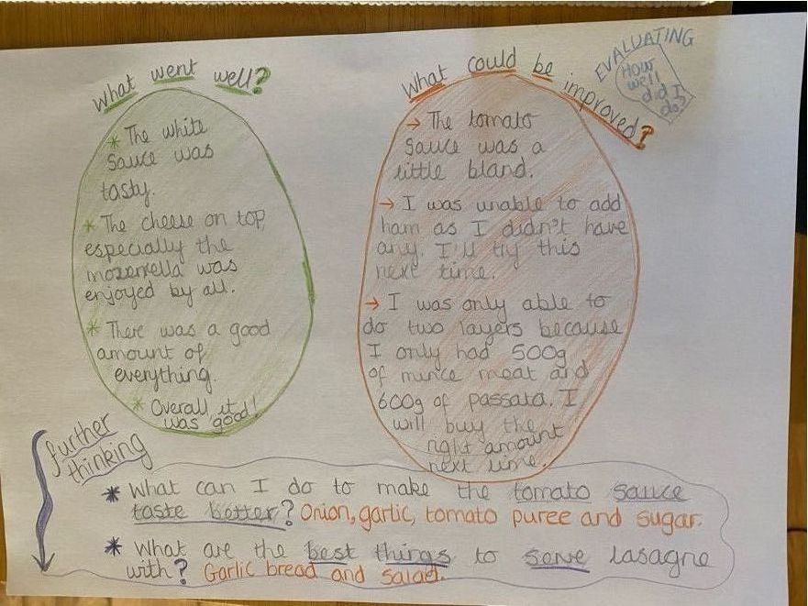
7. Let’s tell someone!
This doesn’t necessarily need a page in your book because this is where you share your learning with others.

8. What have I learned?
(example from exercise challenge and nutrition challenge)
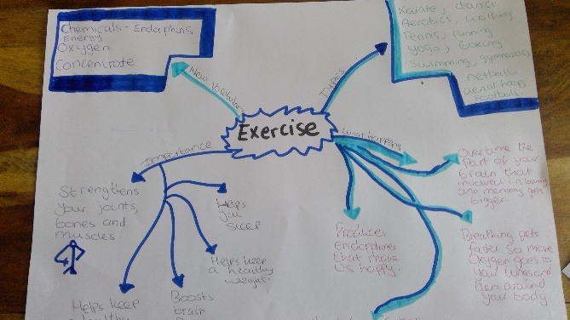

Please note that the examples provided have been created by teachers from reception to year 6.
There are lots of different ways of presenting work from each stage. Be creative in your approaches to each challenge.
The quality and quantity of the work produced will differ according to the age and ability of your child. For examples of other children’s work you can visit each classes celebration pages.

