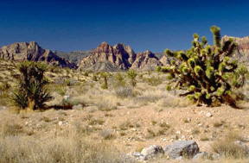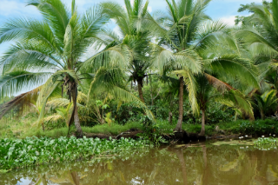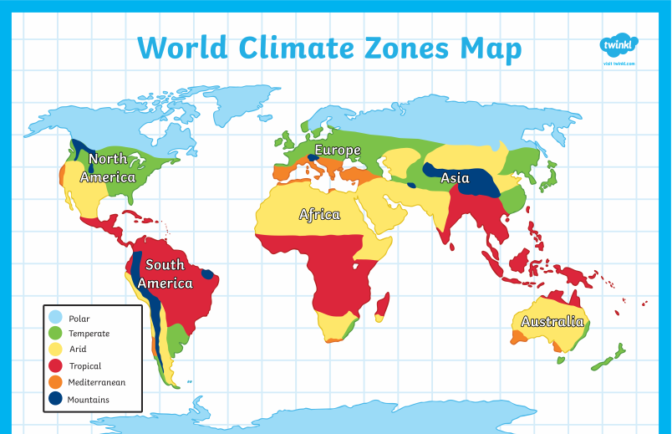**Climate Zones around the world**

**Arid Climate**

In an arid climate, the weather is not extreme hot (there are cold deserts too!) and dry with very little rainfall.

Three arid places I know are;

The Outback (Australia)

Cairo (Egypt)

Atacama Desert (Chile)

**Temperate Climate**

In a temperate climate, the weather is not extreme (not very often anyway!) and there are seasons.

Three temperate places I know are;

London

Paris (France)

San Diego (USA)

**Tropical Climate**

In a tropical climate, the weather is hot and wet. There is lots of rain and temperatures are very high.

Three tropical places I know are;

Mexico

Thailand

Cairns (Northern Australia)