Time | Learning
9-9:30 | Joe Wicks virtual PE – bodycoachtv on youtube.com
9:30 – 9:50 | Guided reading  This week we are looking at letter writing and so our guided reading will be working on this. Use the letter text from yesterday and answer the questions. There is an extension for those who would like to do a bit extra and the answers are at the bottom. Each day the questions will be working on a different area of reading (skill).
9:50-10:30 | LO: to generate ideas about who we could write our letter to as a ‘random act of kindness’  SC1: I create a list of people and reasons why I should write to them  SC2: I can choose one of my ideas as the most appropriate  SC3: I can justify my choice using reasoning related to the task  As you know the purpose of the ‘2020 – a year of change’ challenge is to do random acts of kindness which will make ourselves feel good but also make someone else feel happy.  https://www.youtube.com/watch?v=87O9u45DLKE  Today I want you to create a list of people you could write to, why you would write to them and what you would write about. Remember your letter needs to bring them joy so are you going to include a photo, a drawing you have done, a story that you know will make them happy, an invitation to something to do after this is over?  Present your work how you feel most comfortable but you must have those key elements in there. Remember, in class I always say to you the first idea you have is not always the best so make sure you come up with at least 3 or 4 different ideas for who to write to.  Now finally, I want you to decide which one you are going to choose. You need to be able to explain why you have chosen them.  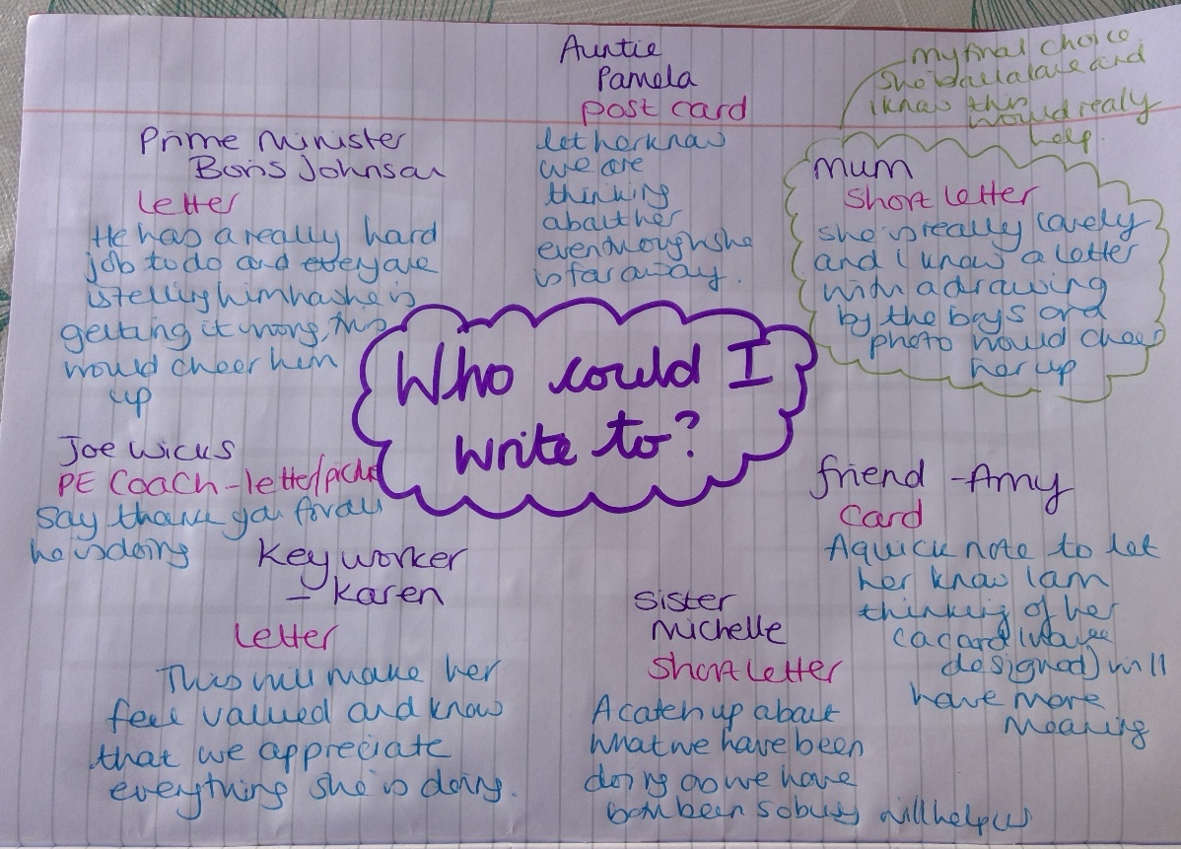
10:30-11:00 | Break time/snack time
11:00 – 11:30 | TTRockstars
11:30- 12:15 | LO: to find a non-unit fraction of a set of objects/numbers  https://whiterosemaths.com/homelearning/year-3/  Click on week 2 lesson 3. Watch the tutorial and then answer the questions. You can use the mark sheet to see how accurate you were.  Extension – non-unit fractions of objects. Year 3 if you are feeling confident then give this a go. Year 4, you pre-existing knowledge of fractions and the revision you have just done should mean that you can complete this. If you are struggling let me know. There is an answer sheet to be able to mark your work.
12:15- 1:15 | Lunch
1:15- 2:15 | LO: to identify things we are grateful for and why  SC1: I can identify things that I am grateful for  SC2: I can discuss why I am grate for these things  Being Grateful  https://www.youtube.com/watch?v=l1kDLHORz-I  As we already know it is easy to think about everything we can’t do at the moment but today I want you to think about all the things you are grateful for. Draw around your hand on a piece of paper, in each outline of a finger write one thing they are thankful for. For example: family, friends or the environment, the beautiful weather etc. Can you put pictures with it This could be drawn or photos or a mix of both? Have a look at mine for examples of what I am grateful for at the moment.  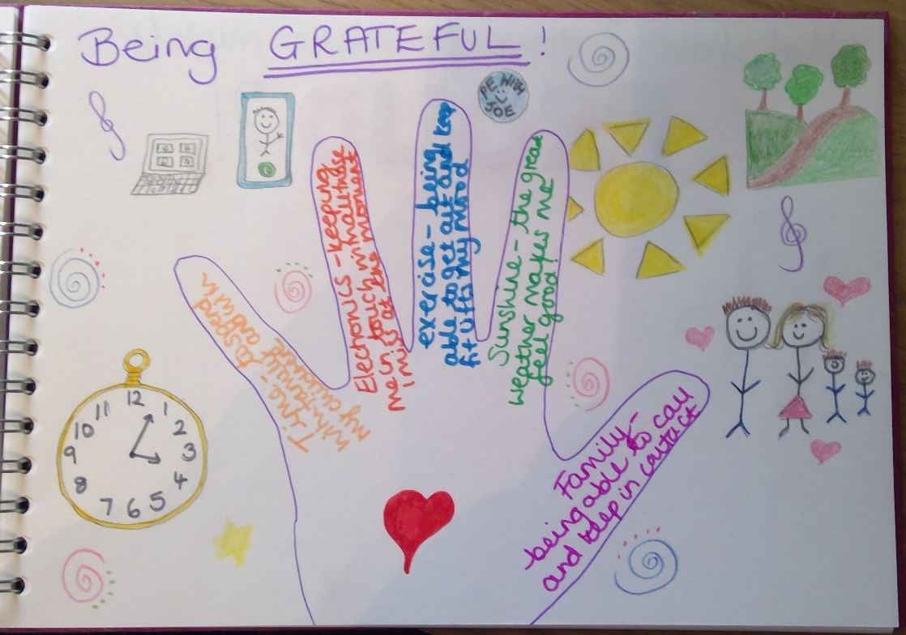
2:15- 2:40 | Exercise – e.g. mindfulness yoga, fresh air in the garden, run up and down the stairs seeing if you can get faster every time!
2:40 – 3:00 | IDL Numeracy – complete the lessons you have been set based on your assessment results. I will be logging in and seeing that you have done this and looking for how much progress you have made.
3:00 – 3:15 | Story time – The Ice Monster read by Mr Cook  https://www.youtube.com/watch?v=uNbcJZhPVPk

