Time | Learning
9-9:30 | Joe Wicks virtual PE – bodycoachtv on youtube.com
9:30 – 9:50 | You choose!  https://youtu.be/dQBPWkqMUvs  Guided reading activity, Spellodrome/Lexia! If you are a lexia person and you choose not to do guided reading you must do Lexia, not Spellodrome.  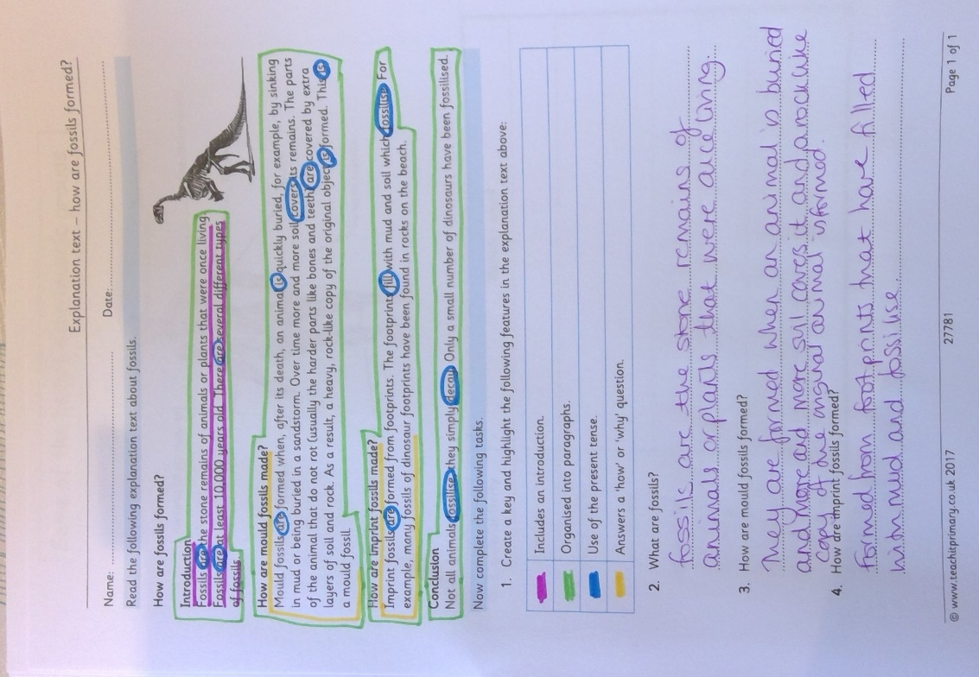
9:50-10:30 | LO: to understand that muscles act in pairs to move the body  SC1: to explain that muscles are connected to the bone  SC2: to understand that to move a bone 2 muscles have to work together  SC3: to discuss that when 2 muscles work together, one relaxes and the other contracts  Watch my video which talk you through how muscles work and read the worksheet to you. https://youtu.be/z71NMqnZC1I  Then use a highlighter to pick out the information that relates to the answers and write an answer to each question. I have included the answers to help you.  Mark your work and see if you can explain in your own words how muscles work to someone in your family.  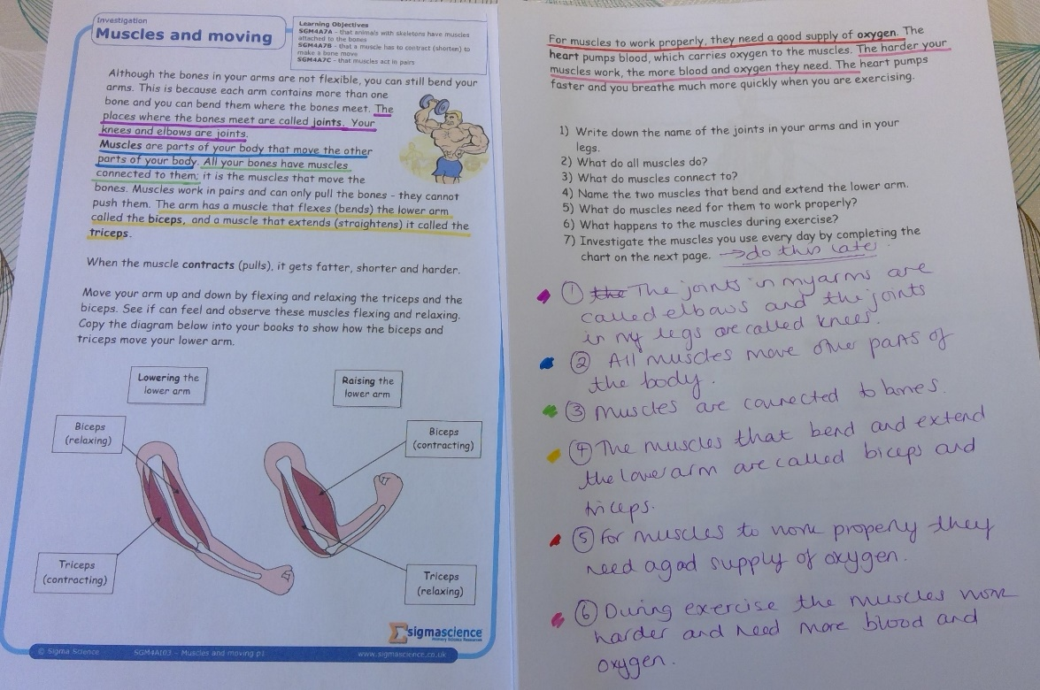
10:30-11:00 | Break time/snack time
11:00 – 11:30 | TTRockstars  Please complete at least 1 studio session and 1 soundcheck.
11:30- 12:15 | https://whiterosemaths.com/homelearning/year-3/  Equivalent fractions worksheet (Summer term week 1W/C 20/04 lesson 1)  https://www.youtube.com/watch?v=P81J7XNzTUY  I am not going to set the extra challenge this week as some of you were beginning to struggle. This lesson goes back to equivalent fractions. I have put a fraction wall on the webpage to help you and these are great for identifying where 2 different fractions are worth the same amount e.g. 2/4 and ½.  If you want to do a bit extra, I have set some fractions work on MyMaths which goes over your prior learning and consolidates this current learning. It is on there for the week so only do a maximum of 2 activities per day.
12:15- 1:15 | Lunch
1:15- 1:50 | LO: to identify and label the muscles in the human body  SC1: to locate major muscle groups in the human body  SC2: to label muscle groups in the human body  I have attached a picture of the human body with some of the major muscle groups labelled. Some of them you might be aware of already. Do some research to find out the names of some of the other muscles. Once you have found 3 or 4 more that you are likely to use in your own exercise video have a go at the very quick quiz below. Here are some websites with some of the muscle names that you could use.  https://www.dreamstime.com/stock-illustration-vector-cartoon-illustration-human-muscular-system-kids-color-muscles-scheme-image77537057  https://stormlynna.wordpress.com/2014/05/30/the-muscular-syestem/  https://www.pinterest.co.uk/pin/292452569524779316/  Have a go at completing the activity below. It lets me know how well you got on so make sure you enter your name.  https://wordwall.net/play/046/053/916
1:50- 2:20 | Exercise – e.g. mindfulness yoga, fresh air in the garden, run up and down the stairs seeing if you can get faster every time!
2:20-3:00 | LO: to show which muscles are being used when exercising  SC1: to locate the major muscle groups in the human body  SC2: to identify which muscles are being used in specific exercises  In order to plan your exercise video/routine you will need to think carefully about the purpose of it. Once you’ve decided the purpose e.g. stretching, strengthening etc you will decide which exercise to include. Before you can do any of this you need to be able to recognise some of the major muscle groups but you also need to know which ones are used during specific exercises so that you can use exercise that achieve your end goal.  https://www.youtube.com/watch?v=m2mwSZL8yZo  Use the labelled diagram to work out which muscles are being used in each of the exercises I have given you in the table.  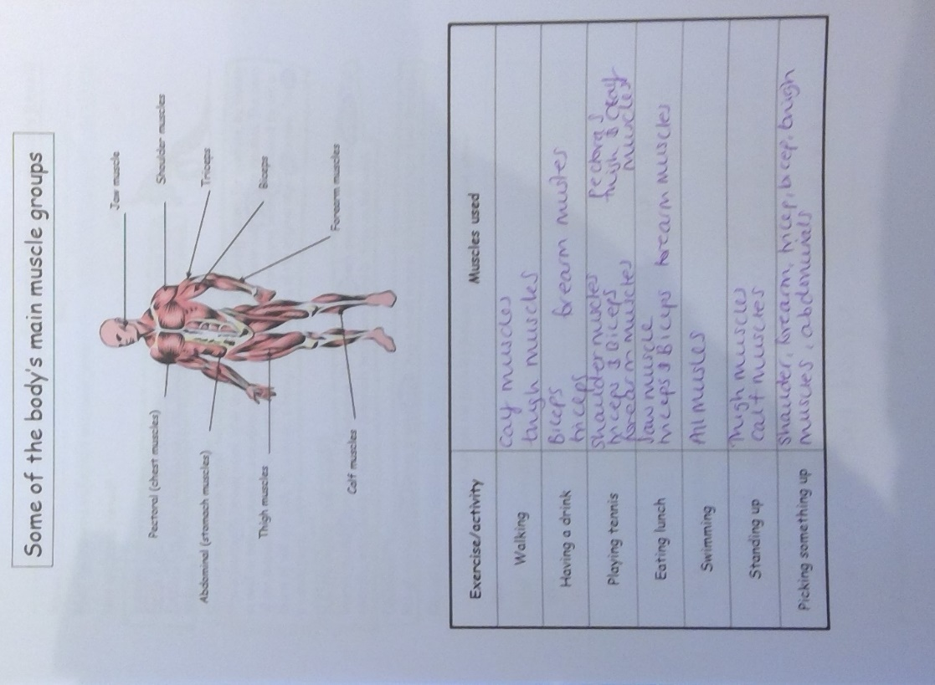
3:00 – 3:15 | Federation Story Time

