Time | Learning
9-9:30 | Joe Wicks virtual PE – bodycoachtv on youtube.com
9:30 – 10.00 | Guided reading  Read the text and answer the questions below the writing.  Watch the video to find out the answers.  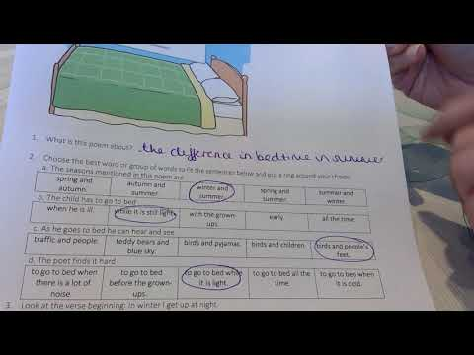
10:00-10:45 | LO: to understand how expanded noun phrases add important detail to build a picture  To write expanded noun phrases  SC1: I can explain what a noun is  SC2: I can list interesting adjective to create description  SC3: I can use effective expanded noun phrases to describe a view  Go onto BBC bitesize to understand what an expanded noun phrase is: https://www.bbc.co.uk/bitesize/topics/zwwp8mn/articles/z3nfw6f  Play Description Challenge using Challenge Picture from the Expanded Noun Phrases word document.  The picture I have given you for the challenge is an example of a still life. It’s a collection of objects that artists put together and then drawn and paint carefully. We are going to use still life collections to help us to write descriptively. Use Extended Noun Phrase PowerPoint, slides 1-6 to explore expanded noun-phrases using adjectives.  Practise: Watch my video to explain how you are going to use still life to practise expanded noun phrases.  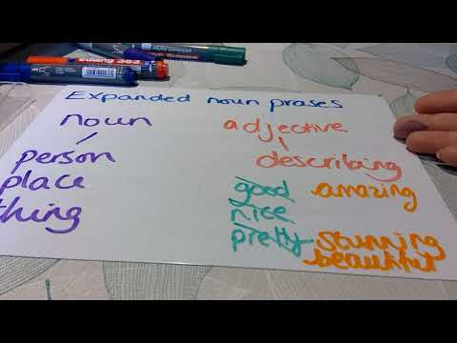  Look at the Flower Picture. What phrases could we use to describe this still life?  Activity  Everything we are doing is leading towards us writing our poem at the end of the week.  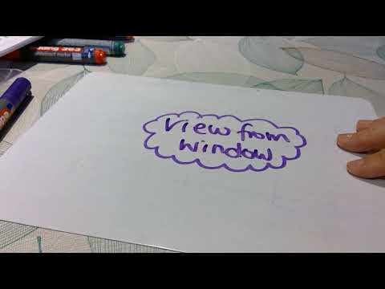  Have a look at the various views from the rooms in your house. Can you go back to the photos from Monday and recall the view you saw. Do you prefer the view at different times of day? Come up with as many different expanded noun phrases as you can to describe the views. You can write this as a list (bullet points is fine).  Extension: can you use some prepositions to extend your descriptive phrases. Use the noun, adjective and preposition sheets to support you.
10:45-11:00 | Break time/snack time
11:00 – 11:30 | TTRockstars
11:30- 12:15 | LO: to memorise the meaning of tenths and identify tenths of objects, shapes and items  SC1: I can explain how to find a tenth  SC2: I can identify a tenth of objects, shapes or items  SC3: I can explain how to find a tenth of objects, shapes or items  https://whiterosemaths.com/homelearning/year-3/  Click on week 1 lesson 3. Watch the tutorial and then answer the questions. You can use the mark sheet to see how accurate you were.  Extension – Recognise and count in tenths. Year 3 if you are feeling confident then give this a go. Year 4, you pre-existing knowledge of fractions and the revision you have just done should mean that you can complete this. If you are struggling let me know. There is an answer sheet to be able to mark your work.
12:15- 1:15 | Lunch
1:15- 2:00 | LO: to experiment with different mediums for drawing a landscape and evaluate their effectiveness  SC1: I can select various mediums from drawing  SC2: I can experiment with different ways of creating a landscape  SC3: I can evaluate which is best and select one for my final version  Now you are going to have a go at creating another landscape but this time we are going to experiment with different ways of adding colour. Choose a place from a window that you particularly enjoy. This might not be the landscape you use for your final picture so don’t worry too much if you change your mind later down the road. You might choose to take a photo and work from that or you might like to sit and draw from real life. Whichever you find appropriate for you is fine. Now you need to do a pencil outline of the landscape. Don’t worry about all the tiny details for this first attempt. Get as many features in as you can but just with an outline.  You may not have all of these materials at home, I know I certainly don’t, but select a few different ones and try them out. The idea is to try out as many different ways of adding colour to your piece so you can choose your favourite. For each medium, I have added some suggestions of styles to use. I have also given you some picture examples. Experiment and see which one works best for you.  - lead pencils,  - experimenting with HB, B, 2B, 3B, 5B etc. to discover the different qualities of lead types (3B = very soft, B = soft, HB = between hard and soft, H = hard, 3H = very hard, etc.);  - applying light and heavy pressure to the pencil tip to make hard and soft lines;  - using a range of hard and soft lines in a drawing to record detail, distance, foreground, shadows etc; and  - trying not to use erasers.  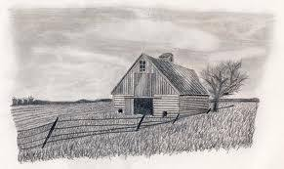  - coloured pencils,  - layering colours to produce a greater depth of colour and range of tones;  - blocking in colour by working with pencil strokes all applied in the same direction; and  - controlling depth of colour by applying different pressures on the pencil tip.  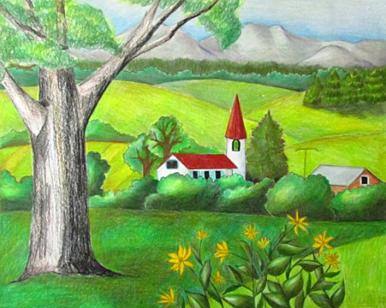  - wax crayons,  - experimenting with pressure to achieve bold and light lines;  - using a wash of ink or paint over a wax crayon drawing;  - preparing a drawing surface by colouring in a solid area with coloured crayons  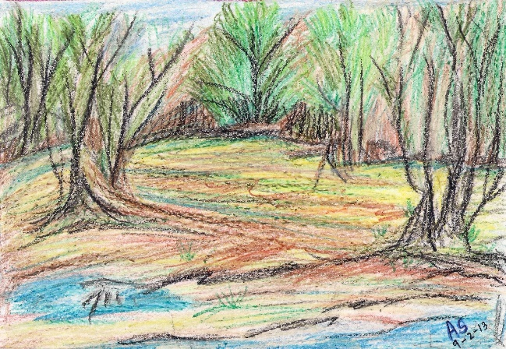  - charcoal,  - making marks and smudging/rubbing to soften the effect; and  - varying the thickness of lines, making soft and strong lines by applying different pressures on the charcoal.  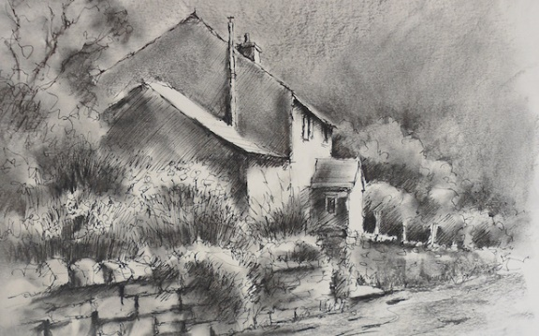  - pens,  - working with a variety of pen types  - making a variety of lines which are free-flowing, sweeping, broken, faint, hard etc. using pens to record minute detail.  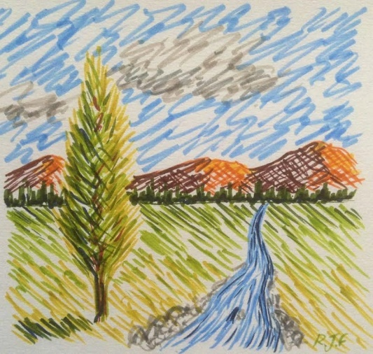  - soft chalky pastels,  - using the side of the pastel to build up layers of colour;  - using the tip of the pastel to create detail;  - blending and overlaying colours to create soft backgrounds, using fingers to smudge;  - working on top to create detail  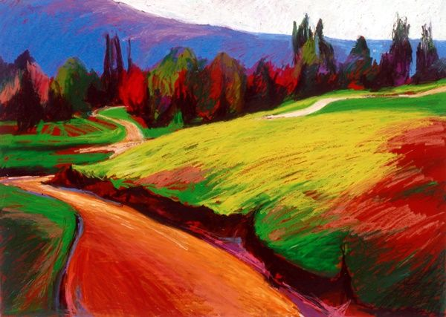  - oil pastels,  - overlaying colours to create new colours and rich textural effects; and  - experimenting with techniques described under wax crayons above.  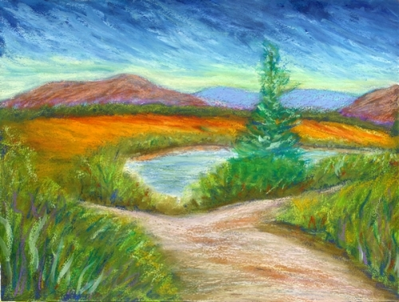  - paint,  - mixing and matching colours for a purpose  - working with different consistencies of paint to produce a range of effects, such as:  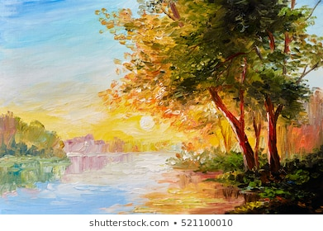
2:00- 2:30 | Exercise – e.g. mindfulness yoga, fresh air in the garden, run up and down the stairs seeing if you can get faster every time!
2:30-3:00 | Keep going with trying out the different mediums. I have given some examples of what I have done. I have done more than one attempt with each type of utensil as I need to practise my skills of tine as well as just using this different way of creating colour/depth. You can do small pictures like mine or use an A4 page for each, the choice is yours. I found the various different mediums really tricky and will need to continue to practise but you can see how I am getting on so far.  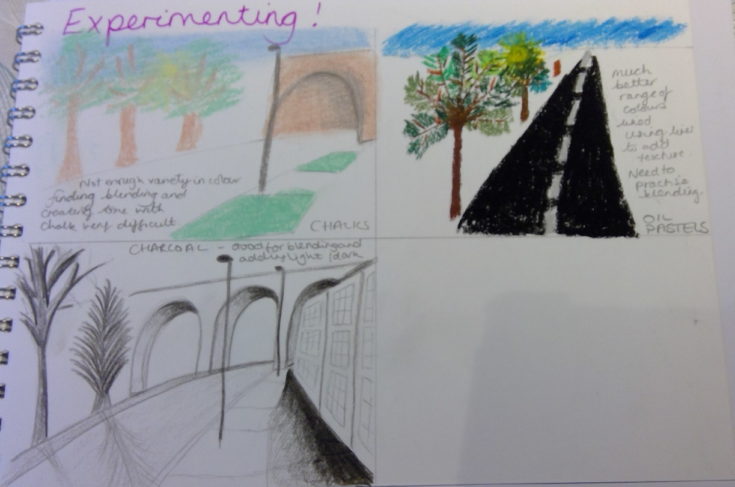
3:00 – 3:15 | Story Time – The Ice Monster  