Time | Learning
9-9:30 | Joe Wicks is no longer running on a Thursday but you can go back and do one of your favourites from his other workouts. Or alternatively you could have a look at other exercise options e.g. cosmic Yoga, Just Dance, Zumba, Les Mills for kids etc.  Get yourself moving and exercising as it will set you up for a great day of learning!!
9:30 – 9:50 | If you are a Lexia person you must complete Lexia during this time instead of guided reading.  Today your guided reading questions are based on SPaG but using the text for reference. You will be looking at areas such as word classes, synonyms, and cloze activities.
9:50-10:30 | LO: to use calculate the perimeter of rectilinear shapes  SC1: I can explain what a rectilinear shape is  SC2: I can describe what the perimeter is and how to find it  SC3: I can use known facts to work out missing information  Year 3:  https://kids.classroomsecrets.co.uk/resource/perimeter-of-rectilinear-shapes-video-tutorial/  Once you have watched the video, have a go at completing the 2 work sheets I have attached at the bottom of the page.  If you get time have a go at the extension.  Year 4:  Today we are going to be using a White Rose maths to help us with our work. Watch the video below. You will find it under year 4, Summer term week 4, lesson 3.  https://whiterosemaths.com/homelearning/year-4/  Once you have watched the video, have a go at completing the 2 work sheets I have attached at the bottom of the page.  If you get time have a go at the extension.
10:30-11:00 | Break time/snack time
11:00 – 11:45 | LO: to write a first draft of a non-chronological report about a world leader  SC1: I can use the features of a non-chronological report  SC2: I can change my notes into full sentences and paragraphs  SC3: I can create a report about a world leader  https://youtu.be/SAkkpT68_A4  We are at the ‘Let’s do it!’ part of our tasc wheel. Now you understand how to write a non-chronological report and you have all the information about the leader you want to write about you are going to put it into practise. Things to think about before you start:  How are you going to design your report – what will it look like on the page?  Are you going to include pictures – have you got the pictures you need?  Have you got all the information you need to include?  What sections will you split it into?  Consider designing your layout before you start writing. Alternatively, as you are going to type this up for your final product, you could write in paragraphs under subheading for each section.  Have a look at my examples to help guide you in how to achieve this.  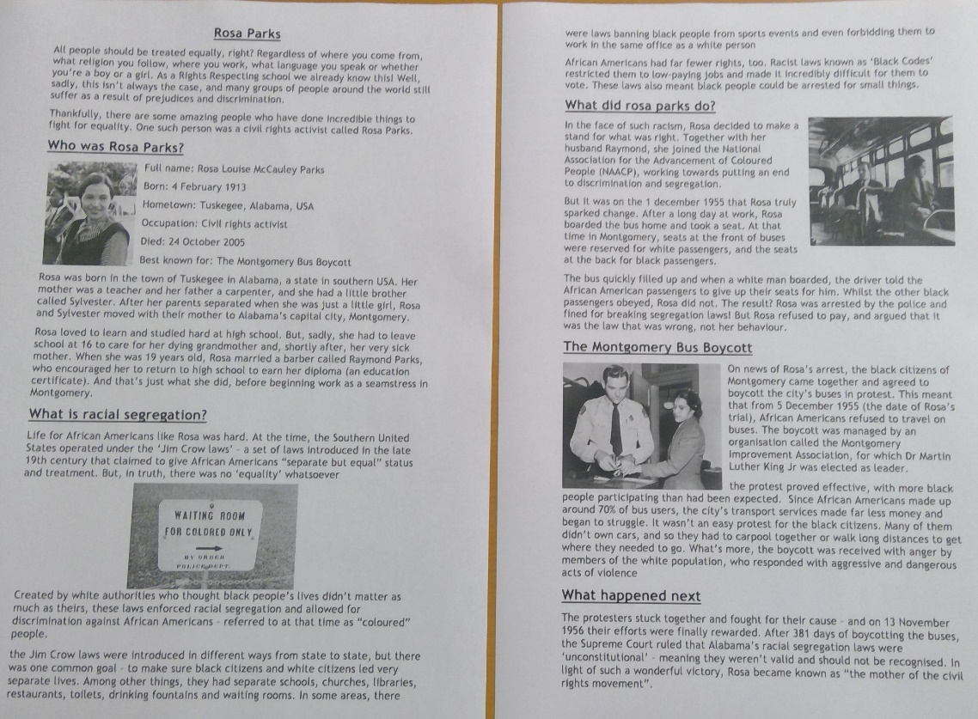
11:45- 12:15 | TTRockstars  Make sure you do at least one sound check and one studio session. Try to get as many right as you can in the fastest time possible. Remember you want to be aiming for less than 6 seconds to answer a question correctly.
12:15- 1:15 | Lunch
1:15- 2:00 | LO: to edit and improve my work  SC1: I can identify spelling mistakes (at least 4) and use an appropriate strategy to change them  SC2: I can find and correct at punctuation mistakes including CL and FS (at least 4)  SC3: I can identify at least 3 sentences that I can improve by up-levelling my choice of language or detail  https://youtu.be/Y2KbBBZa3-I  At this stage in our learning we always take time to reflect on what we have done and decide how to make it better. Professional writers, for example, don’t write their book and then send it straight to be printed. They check it themselves to see what they can do to improve and they ask someone to proof read it and give them feedback. They then make changes to get the best possible final product. If you have someone at home to help you then ask them to give you some constructive feedback. Get out the features of a non-chronological report again and make sure you have included them all – can they identify them in your work? Are there any spelling mistakes that need to be corrected? Have you missed any words, capital letters or full stops that can be put in now so that your work makes sense? Finally, try to find 3 places in your work where you can improve your writing. This could be by choosing more adventurous language, using a thesaurus to find synonyms for words you have used more than once or by using conjunctions to extend a sentence to include more detail. Take your time doing this and making sure you have been through the whole text and pictures that you have included. When you come to write up your final version, you want it to be the best it can be and this only happens y patiently going through the editing and re-drafting process. If you do not have an adult at home who can help you with this. Get a highlighter and see if you can identify these things yourself.  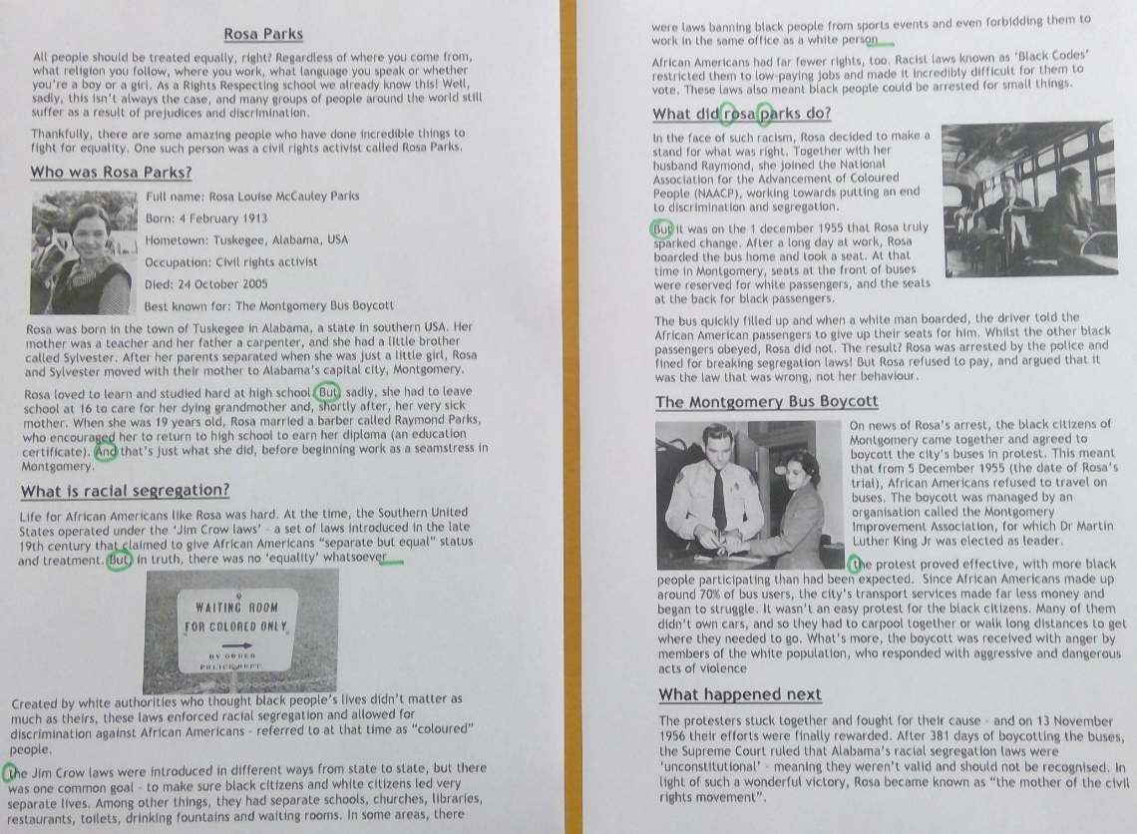
2:00- 2:30 | Exercise – e.g. mindfulness yoga, fresh air in the garden, run up and down the stairs seeing if you can get faster every time!
2:30-3:00 | Lo: to write a non-chronological report  SC1: I can publish my final piece making sure I have included the improvements I made  SC2: I can check my work for the features of a non-chronological report  https://youtu.be/-W9cTNisVGU  Now that you have written and checked your work, responding to feedback or making corrections you have identified, it is now your opportunity to publish your work to create the best possible final product. If you are able to type up your work on a computer and import pictures, then please do so. Make sure you think carefully about the formatting of your work and that it is laid out using the features of a non-chronological report. You only have a short time this afternoon to do this but do not worry, you will be finishing this tomorrow during the English session so there is plenty of time to make it absolutely amazing!!
3:00 – 3:15 | Federation Story Time!!  https://youtu.be/cYCbKue9QFE

