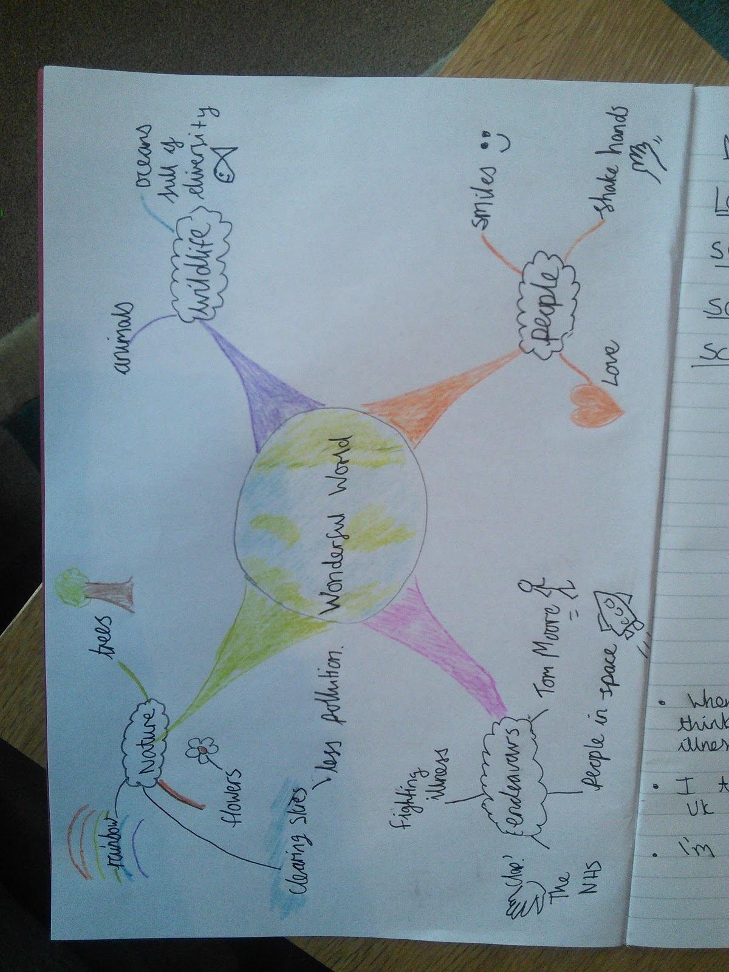
Monday 15th June 2020
Challenge Task
Creating a mind map
Wonderful world
Here are the things mentioned in the song
Trees of green
Red roses blooming
Skies of blue
White clouds
Bright days/dark nights
Rainbows
People’s faces
People shaking hands
Love
Babies crying

When I think about the world, I think about all those fighting illness on a daily basis
I think about how great the wildlife here is
I’m amazed we can go into space

