Time | Learning
9-9:30 | Joe Wicks virtual PE – bodycoachtv on youtube.com
9:30 – 9:50 | If you are a Lexia person you must complete Lexia during this time instead of guided reading.  Those of you doing the guided reading, there are questions related specifically to understanding the text and there is a n activity based around a SPaG focus. Try to complete both if you can but if you run out of time do not worry. Where the questions are about the text, there is the letter AF and a number at the end. This just identifies which reading skill is being focussed on and is nothing for you to worry about. The answers are at the bottom of the sheet so that you can mark your work.
9:50-10:30 | LO: to compare and classify different types of quadrilaterals.  SC1: I know the names and properties of different quadrilaterals.  SC2: I can compare quadrilaterals based on their mathematical properties.  SC3: I can classify quadrilaterals based on their mathematical properties.  https://www.youtube.com/watch?v=VOWLt7lCOlU  Comparing Quadrilaterals: Looking at the selection of different quadrilaterals displayed, discuss ways in which they are the same, and ways that they are different.  Quirky Quadrilaterals: Read the information on the Lesson Presentation to explain that all four sided shapes can be classified as quadrilaterals, and then to introduce the mathematical properties of different quadrilaterals.  Comparing Quadrilaterals Activity: - Choose your challenge. 1 star is the easiest and 3 star is the hardest. If you choose a challenge and it is too hard, don’t finish it, swap to an easier one. Similarly, if you choose one that is too easy, swap to a harder one. Think about which star challenge I normally give you at school.  If you finish this and you want an extension, I have added one but do not spend ages doing this. Only do the extension is you have time. This will really work on your justification and reasoning which is a very important part of your maths curriculum. Year 4 you should definitely give this a go if you have time.  Guess My Quadrilateral: Looking at the selection of different quadrilaterals displayed, one child tries to deduce which quadrilateral the other is thinking of by asking questions about its mathematical properties.
10:30-11:00 | Break time/snack time
11:00 – 11:45 | Decide – Which idea is the best  LO: to choose the most appropriate recipe  SC1: I can identify which recipe is healthy and balanced  SC2: I can decide which recipe I can cook  SC3: I can justify why I chose this recipe  https://www.youtube.com/watch?v=mxsvQIhuMRU  Now that you have thought about all your possible options you need to choose the one you are actually going to do. Write out the ingredients and the step to the recipe. This is your opportunity to work on presentation – think of it like a display piece. Use good punctuation, CL and FS, joined handwriting and the correct features of a recipe.  Complete your chosen recipe with pictures. Imagine this will be published in a recipe book and it needs to be the best piece you can do. Remember we are always trying to be experts at what we do and we have worked on recipes in an earlier challenge.  Use the final stage of writing your recipe to explain why you chose this recipe and how it fits the brief that we were given by Miss Fermor and Mrs Mitchell.  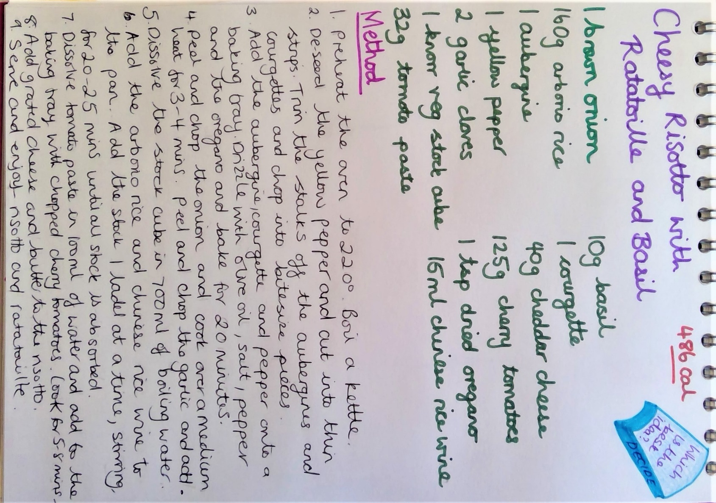
11:45- 12:15 | TTRockstars  Make sure you do at least one sound check and one studio session. Try to get as many right as you can in the fastest time possible. Remember you want to be aiming for less than 6 seconds to answer a question correctly.
12:15- 1:15 | Lunch
1:15- 2:00 | Let’s do it!  With help where you need it, remembering everything you learned about health and safety from our previous experience and challenges, cook your chosen recipes. Take photos of your cooking journey and the final product for your records. We want to celebrate our achievements!  Once you have cooked your recipe, have a taste test. Get as many people in your house to try is as possible and get their verdict on it. Is it delicious? Is it filling? Does it taste healthy? What would they give it out of 10? Can you get any feedback about how it could be improved?
2:00- 2:30 | Exercise – e.g. mindfulness yoga, fresh air in the garden, run up and down the stairs seeing if you can get faster every time!
2:30-3:00 | If your cooking and taste testing takes longer than the allotted time earlier, then don’t do this activity. However, if you have time make some notes about what the feedback about your cooking was ready for your work tomorrow.
3:00 – 3:15 | Federation Story Time – The Ice Monster  https://www.youtube.com/watch?v=L6NG8ugbiq8

